CTM-I Use Case

Back-Door FUO

Version 0.1

Use Case Name | Back-Door Futures Delete
Actor | App Support
Pre-conditions /Assumptions | User has Browser and is aware of the http path to the application.  User has successfully logged into the CTM-I application.  User has the right role to see the menu options.
Post Conditions | None
Screenshot | 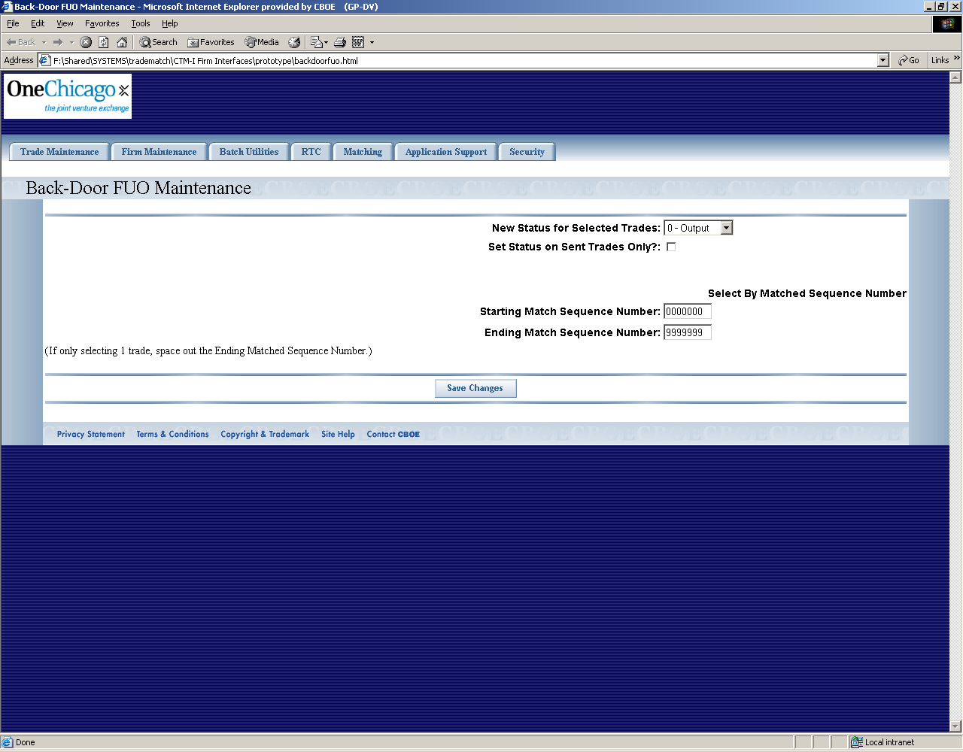
Flow of Events | - User selects “Back-Door FUO” from the menu.  - Back-Door FUO screen displays  - User enters a new status of trades selected, Output or Resend or Sent. Output will send trades immediately back to CME, Resend will send back to CME on a timer, Sent will mark trades to not be forwarded to the CME.  - User can optionally Set Status on Sent Trades Only. If sequence of trades is selected then user can optionally request that only sent trades be changed and forwarded to the CME.  - User selects starting and ending sequence number. If only one trade is requested than the ending sequence number is left blank.  - Request is sent to CTM-R to reset status on trades selected on screen.  - Any feedback from CTM-R is displayed on the screen.
Alternative Path | Any errors, including record not found, from CTM-R are displayed on the screen.

